**Software Requirements Specification**

***Air Traffic Control System***

Version:

October 31, 2018

Document ID: 00001

***Development Team ATCDev***

**Development Team Members:**

|  |  |
| --- | --- |
| **Student Number** | **Student Name** |
| 20165164 | Peiyi Yang |
| 20165187 | Geping Chen |
| 20165140 | Jianxiang Wang |

**Table of Contents**

Version History iii

1.0 Introduction 1

2.0 Use Case Packages 2

2.1 Package Diagram 2

2.2 Package Descriptions 2

3.0 Use Case Diagrams 3

3.1 Monitor 3

3.2 Communicate 3

3.3 Schedule 3

4.0 Actor Descriptions 3

5.0 Use Case Summaries 3

6.0 Use Case Descriptions 4

6.1 Get aircraft location 4

6.2 Monitor safe distance 6

6.3 Display landing sequence 6

6.4 Remove cancled aircraft from the queue 6

6.5 Add new aircraft to queue 6

6.6 Change priority of the queue 6

6.7 Send instructions 6

6.2 Broadcast 6

7.0 Activity Diagrams 7

7.1 Change aircraft's priority 7

7.2 Add new aircraft to landing queue 7

7.3 One-to-One Instructions 8

7.4 Monitor boarder 9

8.0 Non-Functional Requirements 10

9.0 Release Plan 11

9.1 Release One 11

9.2 Release Two 11

9.3 Release Three 11

9.4 Release Four 11

9.5 Release Five 11

10.0 Glossary 12

11.0 Summary 13

12.0 References 14

# Version History

|  |  |  |
| --- | --- | --- |
| **Issue** | **Date** | **Change** |
|  | 30/10/2018 | Initial version. |
|  | 31/10/2018 | Re-design the whole system.  Add use case diagrams. |
|  | 1/11/2018 | Delete the actor of Grand Staff.  Remove Grand Stuff from use case diagrams.  Add activity diagrams.  Add release plans. |
| None | 2/11/2018 | Add introduction, summary and references. |

# 1.0 Introduction

The air traffic controller system is specially designed to track all aircraft flying in the country’s airspace.

Consideing the jobs of the ATC, there are 3 main functions we are planning to implement.

1) moniter all aircraft flying in the country’s airspace,

2) communication with the pilot,

3) arrange the sequence of the landing and departure queue.

Considering the development of oursystem, our stakeholders have two main groups

1) who interested in project/ system outcomes

2) who interested in project conduct, in other words, our teams.

For people who are interested in project outcomes, the government and the airline company are the main sponsors of our project, which means we specially design the system for them to well manage the country’s air traffic and as a result, brings big incomes. The air traffic controller are the main users of our system, which means it is needed to be useful and easy to use.

In our requirements specification, we draw the package diagram, use case diagram, and activity diagram of the functions and we write the the use case description and the glossary of the cases and the noun.

# 2.0 Use Case Packages

## 2.1 Package Diagram

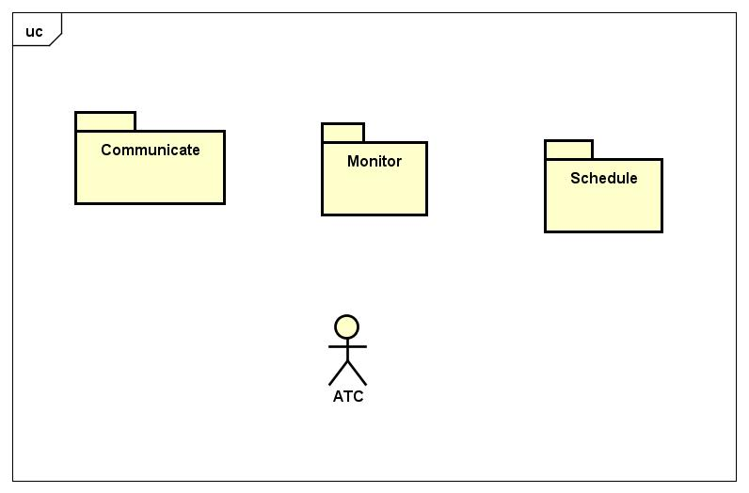

## 2.2 Package Descriptions

|  |  |
| --- | --- |
| **Package Name** | **Description** |
| Communicate | The interactions between ATC and Communication Syatem. |
| Schedule | The activities of managing the landing and departure order of aircrafts. |
| Monitor | The activities of monitoring aircraft safety and zone boarders. |

# 3.0 Use Case Diagrams

## 3.1 Monitor

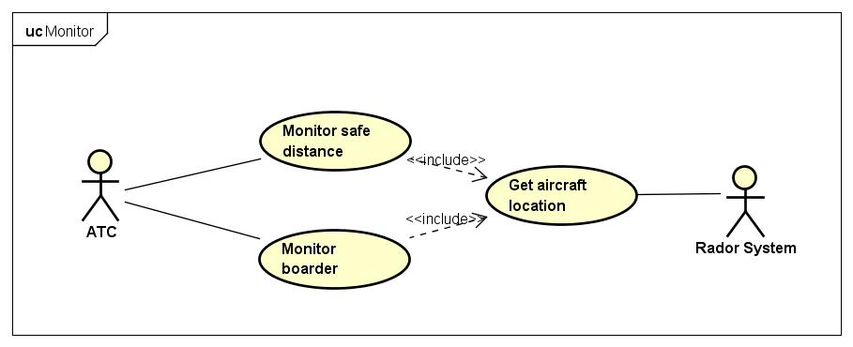

## 3.2 Communicate

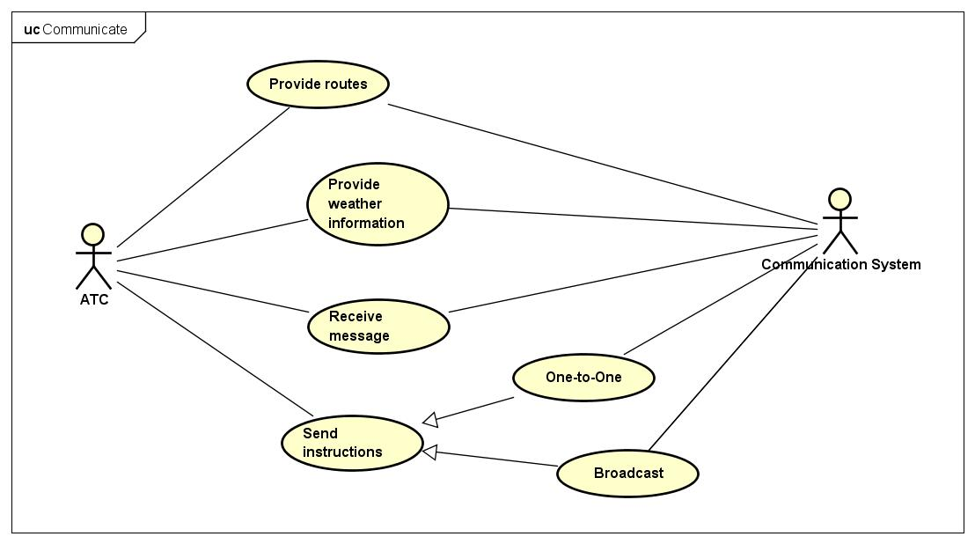

## 3.3 Schedule

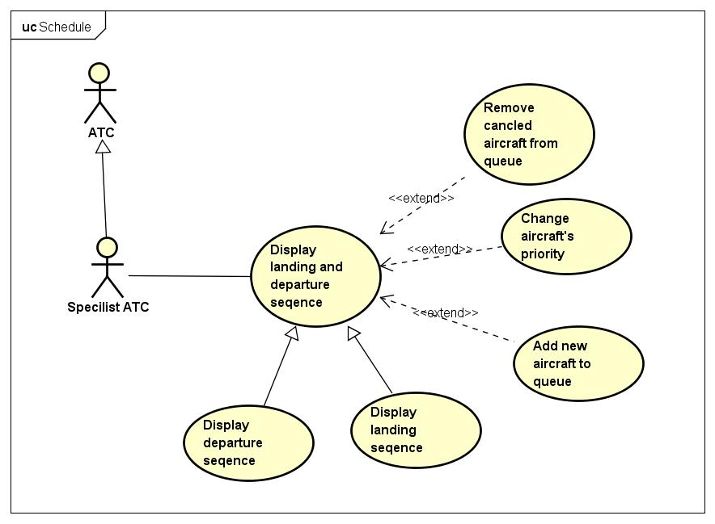

# 4.0 Actor Descriptions

|  |  |
| --- | --- |
| **Actor Name** | **Description** |
| ATC | The person who controls air traffic at the airport. |
| Specialist ATC | A special ATC who schedules the landing order of aircrafts. |
| Communication System | The person who flies the plane. |
| Radar system | The system on the aircraft that uses GPS, radars, sensors, etc, to locate the plane. |

# 5.0 Use Case Summaries

|  |  |
| --- | --- |
| **Use Case** | **Summary** |
| Get aircraft location | ATC gets the location of aircrafts through Radar System. |
| Monitor safe distance | System should alert ATC when two aircrafts are closer than the safety distance. |
| Monitor boarder | System should check if there are aircrafts entering and leaving ATC’s zone. |
| Provide routes | ATC provides possible routes to polits. |
| Provide weather information | ATC provides weather information to pilots. |
| Receive message | ATC receives messages sent from pilots. |
| Send instructions | ATC gives instructions to all pilots or a certain pilot. |
| On-to-One | ATC selects a certain pilot and sends him insructions |
| Broadcast | ATC sends instructions to all pilots in ATC’s zone. |
| Display landing and departure seqence | System displays the current landing and departure order of airplanes to Specialist ATC |
| Display departure seqence | System displays the current departure order of airplanes to Specialist ATC. |
| Display landing seqence | System displays the current landing order of airplanes To Specialist ATC. |
| Add new aircraft to queue | Specialist ATC can add an aircraft to the current landing or departure queue if the flight is newly added. |
| Remove cancled aircraft from queue | Specialist ATC can remove an aircraft from the current landing or departure queue if the flight is canceled. |
| Change aircraft's priority | Specialist ATC can change the priority of an aircraft in the landing queue. |

# 6.0 Use Case Descriptions

## 6.1 Get aircraft location

|  |  |  |  |
| --- | --- | --- | --- |
| **Version** | 0.1 | **Date** | Oct.31, 2018 |
| **Package** | Monitor | | |
| **Summary** | ATC gets the location of aircrafts through Aircraft System. | | |
| **Primary Actor** | ATC | | |
| **Secondary Actors** | Radar System | | |
| **Inherits** | None. | | |
| **Includes** | None. | | |
| **Extension Points** | None. | | |
| **Business Rules** | Every aircraft has an Aircraft System on it that can locate itself using sensors, GPS, etc.  Every airport has a Radar System that can detect the aircrafts in the airport’s zone. | | |
| **Estimate** | 10 Hours | | |
| **Pre-Condition(s)** | None. | | |

Typical Sequence of Events

|  |  |
| --- | --- |
| **Actor Stimulus** | **System Response** |
| 1. Radar System sends location data to System. | 2. System  2.1 validates the location data.  2.2 calculates the location of the aircraft using this data.  2.3 updates the current location of the aircraft. |
| 3. ATC selects an aircraft from his screen and chooses to get its location. | 4. System displays the current location of the aircraft. |

|  |  |
| --- | --- |
| **Post-Condition(s)** | The location of the selected aircraft is displayed on the screen.  The location is stored. |

Alternative Sequences of Events

**Alternative 1: Radar System Failure at step 1**

|  |  |
| --- | --- |
| **Actor Stimulus** | **System Response** |
| 1. Radar System can not send any data. | 2. System displays connection failure message. |

**Alternative 2: Invalid location data at step 3**

|  |  |
| --- | --- |
| **Actor Stimulus** | **System Response** |
| 1. Radar System sends location data to System. | 2. System  2.1 determines location information is invalid.  2.2 displays invalid location data error message |

|  |  |
| --- | --- |
| **Priority** | High |
| **Outstanding Issues** | None. |
| **Author** | Peiyi Yang |
| **Business Owner** | Airline company |
| **Notes** | None |
| **Version History** | 0.1 Initial version. |

## 6.2 Monitor safe distance

|  |  |  |  |
| --- | --- | --- | --- |
| **Version** | 0.2 | **Date** | Oct.31, 2018 |
| **Package** | Monitor | | |
| **Summary** | System should alert ATC when two aircrafts are closer than the safety distance. | | |
| **Primary Actor** | ATC | | |
| **Secondary Actors** | Radar System | | |
| **Inherits** | None | | |
| **Includes** | Get aircraft location | | |
| **Extension Points** | None | | |
| **Business Rules** | Aircraft need to maintain a separation of 1000 metres from each other while in normal flight.  As an aircraft gets close to landing the separation between aircraft can decrease to 500 metres. | | |
| **Estimate** | 5 Hours | | |
| **Pre-Condition(s)** | The current and previous locations of each aircraft are known to system. | | |

Typical Sequence of Events

|  |  |
| --- | --- |
| **Actor Stimulus** | **System Response** |
| 1. <<include>> Get aircraft location | 2. System calculates the distance between the aircraft and other known aircrafts and determines the aircraft is at a safe distance from other airfracts. |

|  |  |
| --- | --- |
| **Post-Condition(s)** | An alert should be sent to ATC if the aircraft is at too close to other aircrafts. |

Alternative Sequences of Events

**Alternative 1: Aircrafts too close at step 2**

|  |  |
| --- | --- |
| **Actor Stimulus** | **System Response** |
| 1. <<include>> Get aircraft location | 2. System  2.1 calculates the distance between the aircraft and other known aircrafts and determines the aircraft is too close to another aircraft.  2.2 sends ATC an alert. |

|  |  |
| --- | --- |
| **Priority** | Very High |
| **Outstanding Issues** | None. |
| **Author** | Peiyi Yang |
| **Business Owner** | Airline company |
| **Notes** | None |
| **Version History** | 0.1 Initial version  0.2 Include Get aircraft location. |

## 6.3 Display landing sequence

|  |  |  |  |
| --- | --- | --- | --- |
| **Use Case Title** | Display landing sequence | | |
| **Version** | 0.1 | **Date** | Oct.31, 2018 |
| **Package** | Schedule | | |
| **Summary** | System displays the current landing and departure order of airplanes to Specialist ATC | | |
| **Primary Actor** | Specialist ATC | | |
| **Secondary Actors** | None | | |
| **Inherits** | Display landing and departure sequence | | |
| **Includes** | None | | |
| **Extension Points** | Add new crafts to queue, change aircraft’s priority, remove cancled aircraft from queue | | |
| **Business Rules** | Every day, the aircrafts plan to land or departure at one airport is fixed.  System will initialize the landing queue every morning when system is ready.  The system will remove the first aircraft from the queue automatically when the planes land at the airport.  Specialist ATC add new aircraft to queue if emergency occur that the aircraft, which is not arranged to land here, must land at our airport.  Specialist ATC change the priority of queue when some aircrafts are in case of emergency to land at airport early.  Specialist ATC will remove the flight from the landing queue that has been cancled because of some unprecedented affairs. | | |
| **Estimate** | 15 Hours | | |
| **Pre-Condition(s)** | None | | |

Typical Sequence of Events

|  |  |
| --- | --- |
| **Actor Stimulus** | **System Response** |
| 1. Specialist ATC chooses to coordinate the sequence of landing queue. | 2. System displays current landing sequence.  2.1 System asks user to choose an operation. |
| 3. Specialist ATC chooses the actions of  <<extend>> remove from the queue OR  <<extend>> change priority of aircraft OR  <<extend>> add aircraft to queue OR  Stay a current. | 4. System opearate the function according to the Specialist ATC’s Choice. |

|  |  |
| --- | --- |
| **Post-Condition(s)** | The system displays the landing order of the queue, and ATC can choose the function to opearate the queue. |

|  |  |
| --- | --- |
| **Priority** | High |
| **Outstanding Issues** | None |
| **Author** | Geping Chen |
| **Business Owner** | Airline company |
| **Notes** | None |
| **Version History** | 0.1 Initial version |

## 6.4 Remove cancled aircraft from the queue

|  |  |  |  |
| --- | --- | --- | --- |
| **Use Case Title** | Remove cancled aircraft from the queue | | |
| **Version** | 0.2 | **Date** | Oct.31, 2018 |
| **Package** | Schedule | | |
| **Summary** | Specialist ATC can remove an aircraft from the current landing or departure queue if the flight is canceled. | | |
| **Primary Actor** | Specialist ATC | | |
| **Secondary Actors** | None | | |
| **Inherits** | None | | |
| **Includes** | None | | |
| **Extension Points** | None | | |
| **Business Rules** | The system will remove the first aircraft from the queue automatically.  The Specialist ATC needs to remove the aircraft from the queue if it is cancled. | | |
| **Estimate** | 50 Hours | | |
| **Pre-Condition(s)** | Specialist ATC choose the removal function. | | |

Typical Sequence of Events

|  |  |
| --- | --- |
| **Actor Stimulus** | **System Response** |
|  | 2. System requests the Specialist ATC to enter the aircraft ID.  2.1 System validate the aircraft ID  2.2 System remove the aircraft from the queue |

|  |  |
| --- | --- |
| **Post-Condition(s)** | Specialist ATC removes the aircraft that has been cancled and show the new order of the queue. |

Alternative Sequences of Events

**Alternative 1: no such ID at step 1**

|  |  |
| --- | --- |
| **Actor Stimulus** | **System Response** |
| 1. Specialist ATC input an aircraft ID that is not exist in the queue. | 2. The system will display the invalid ID message  2.1 Repeat step 1. |

|  |  |
| --- | --- |
| **Priority** | Medium |
| **Outstanding Issues** | None |
| **Author** | Geping Chen |
| **Business Owner** | Airline company |
| **Notes** | None |
| **Version History** | 0.1 Initial version |

## 6.5 Add new aircraft to queue

|  |  |  |  |
| --- | --- | --- | --- |
| **Use Case Title** | Add new aircraft to queue | | |
| **Version** | 0.3 | **Date** | Oct.31, 2018 |
| **Package** | Schedule | | |
| **Summary** | Specialist ATC can add an aircraft to the current landing or departure queue if the flight is newly added. | | |
| **Primary Actor** | Specialist ATC | | |
| **Secondary Actors** | None | | |
| **Inherits** | None | | |
| **Includes** | None | | |
| **Extension Points** | None | | |
| **Business Rules** | Everyday, the aircrafts plan to land and departure is fixed for the airport.  The Specialist ATC needs to add the new aircraft to the queue if an aircraft is added | | |
| **Estimate** | 50 Hours | | |
| **Pre-Condition(s)** | Specialist ATC choose the add function. | | |

Typical Sequence of Events

|  |  |
| --- | --- |
| **Actor Stimulus** | **System Response** |
|  | 2. System requests the Specialist ATC to enter the aircraft ID.  2.1 System validate the aircraft ID |
| 3. Specialist ATC enters the aircraft ID that is planned to add to the queue | 4. System request the Specialist ATC to input the estimated time |

|  |  |
| --- | --- |
| **Post-Condition(s)** | Specialist ATC add the aircraft to the queue and show the new order of the queue. |

Alternative Sequences of Events

**Alternative 1: no such ID at step 1**

|  |  |
| --- | --- |
| **Actor Stimulus** | **System Response** |
| 1. Specialist ATC input an aircraft ID that is not exist in any recording. | 2. The system will display the invalid ID message  Repeat step 1. |

**Alternative 2: same ID at step 1**

|  |  |
| --- | --- |
| **Actor Stimulus** | **System Response** |
| 1. Specialist ATC input an aircraft ID that is already existed in the queue | 2. The system will display the already exist in the queue message  2.1 Repeat step 1. |

**Alternative 3: time must be later than present at step 3**

|  |  |
| --- | --- |
| **Actor Stimulus** | **System Response** |
| 1. Specialist ATC input the time that is earlier than present time. | 2. The system will display the input time ealier than present message  2.1 Repeat step 1. |

|  |  |
| --- | --- |
| **Priority** | Very High |
| **Outstanding Issues** | None |
| **Author** | Geping Chen |
| **Business Owner** | Airline company |
| **Notes** | None |
| **Version History** | 0.1 Initial version |

## 6.6 Change priority of the queue

|  |  |  |  |
| --- | --- | --- | --- |
| **Use Case Title** | Change priority of the queue | | |
| **Version** | 0.2 | **Date** | Oct.31, 2018 |
| **Package** | Schedule | | |
| **Summary** | Specialist ATC can change the priority of an aircraft in the landing queue. | | |
| **Primary Actor** | Specialist ATC | | |
| **Secondary Actors** | None | | |
| **Inherits** | None | | |
| **Includes** | None | | |
| **Extension Points** | None | | |
| **Business Rules** | The system will arrange the order of the queue automatically according to the plan every morning when system is ready.  The Specialist ATC needs to change the priority of the queue when uprecidented things happened. | | |
| **Estimate** | 50 Hours | | |
| **Pre-Condition(s)** | Specialist ATC choose to change priority of the queue function. | | |

Typical Sequence of Events

|  |  |
| --- | --- |
| **Actor Stimulus** | **System Response** |
|  | 2. System requests the Specialist ATC to enter the aircraft ID.  2.1 System validate the aircraft ID |
| 3. Specialist ATC enters the aircraft ID that is planned to add to the queue | 4. System request the Specialist ATC to input the estimated time |

|  |  |
| --- | --- |
| **Post-Condition(s)** | Specialist ATC rearrange the sequence of the queue |

Alternative Sequences of Events

**Alternative 1: no such ID at step 1**

|  |  |
| --- | --- |
| **Actor Stimulus** | **System Response** |
| 1. Specialist ATC input an aircraft ID that is not exist in the queue. | 2. The system will display the invalid ID message  Repeat step 1. |

**Alternative 2: time must be later than present at step 3**

|  |  |
| --- | --- |
| **Actor Stimulus** | **System Response** |
| 1. Specialist ATC input the time that is earlier than present time. | 2. The system will display the input time ealier than present message  2.1 Repeat step 1. |

|  |  |
| --- | --- |
| **Priority** | Very High |
| **Outstanding Issues** | None |
| **Author** | Geping Chen |
| **Business Owner** | Airline company |
| **Notes** | None |
| **Version History** | 0.1 Initial version |

## 6.7 Send instructions

|  |  |  |  |
| --- | --- | --- | --- |
| **Use Case Title** | Send instructions | | |
| **Version** | 0.1 | **Date** | Oct.31, 2018 |
| **Package** | Communicate | | |
| **Summary** | ATC gives instructions to all pilots or a certain pilot. | | |
| **Primary Actor** | ATC | | |
| **Secondary Actors** | Radar System | | |
| **Inherits** | None | | |
| **Includes** | None | | |
| **Extension Points** | None | | |
| **Business Rules** | The aircraft system can get aircrafts’ location to the Air Traffic Control System. | | |
| **Estimate** | 30 Hours | | |
| **Pre-Condition(s)** | None. | | |

Typical Sequence of Events

|  |  |
| --- | --- |
| **Actor Stimulus** | **System Response** |
| 1. ATC selects to give instructions to Pilot | 2. System displays all the aircrafts that they managed in a list on screen. |
| 3. ATC selects the aircraft that needed to be given instructions | 4. System displays a input box on screen |
| 5. ATC enters the instructions details | 6. System saves the instruction details and sends it to aircraft. |

|  |  |
| --- | --- |
| **Post-Condition(s)** | A hint which is about whether the instructions is sent successfully is displayed on ATC’s screen. |

Alternative Sequences of Events

**Alternative 1: ATC Execution Failure at step 1&3&5**

|  |  |
| --- | --- |
| **Actor Stimulus** | **System Response** |
| 1. ATC can not perform action. | 2. System displays connection failure message on screen. |

**Alternative 2: System display Failure at step 2&4**

|  |  |
| --- | --- |
| **Actor Stimulus** | **System Response** |
| 1. System can not jump to the next UI. | 2. System  2.1 displays error message onscreen.  2.2 refreshes page. |

**Alternative 2:Instructions Sending Failure at step 6**

|  |  |
| --- | --- |
| **Actor Stimulus** | **System Response** |
| 1. System cannot send it to aircraft. | 2. System  2.1 displays the error message that the details not sent if the instructions not be sent on screen.  2.2 resend the details. |

|  |  |
| --- | --- |
| **Priority** | Very High |
| **Outstanding Issues** | None |
| **Author** | Wang Jianxiang |
| **Business Owner** | Airline company |
| **Notes** | None |
| **Version History** | 0.1 Initial version |

## 6.2 Broadcast

|  |  |  |  |
| --- | --- | --- | --- |
| **Use Case Title** | Broadcast | | |
| **Version** | 0.1 | **Date** | Oct.31, 2018 |
| **Package** | Communicate | | |
| **Summary** | ATC sends instructions to all pilots in ATC’s zone. | | |
| **Primary Actor** | ATC | | |
| **Secondary Actors** | Aircraft System | | |
| **Inherits** | Give instructions | | |
| **Includes** | None | | |
| **Extension Points** | None | | |
| **Business Rules** | The information of flights is stored in database. | | |
| **Estimate** | 20 Hours | | |
| **Pre-Condition(s)** | None | | |

Typical Sequence of Events

|  |  |
| --- | --- |
| **Actor Stimulus** | **System Response** |
| Replace Step 3 in “Sell Insurance Policy”  3.ATC selects all the aircrafts that are managed by it. | Same as Step 2&4&6 in “Sell Insurance Policy” |

|  |  |
| --- | --- |
| **Post-Condition(s)** | A hint which is about whether the instructions is sent successfully is displayed on ATC’s screen. |

Alternative Sequences of Events

**Alternative 1: Instructions Sending Failure at step 6**

|  |  |
| --- | --- |
| **Actor Stimulus** | **System Response** |
| 1. ATC can not send information about searching. | 2. System  2.1 lists a list of aircraft IDs of aircrafts that failed to be given instructions.  2.2 displays the error message that the details not sent if the instructions not be sent on screen.  2.3 resends the instructions to the aircrafts that failed to be given instructions. |

|  |  |
| --- | --- |
| **Priority** | High |
| **Outstanding Issues** | None |
| **Author** | Wang Jianxiang |
| **Business Owner** | Airline company |
| **Notes** | None |
| **Version History** | 0.1 Initial version |

# 7.0 Activity Diagrams

## 7.1 Change aircraft's priority

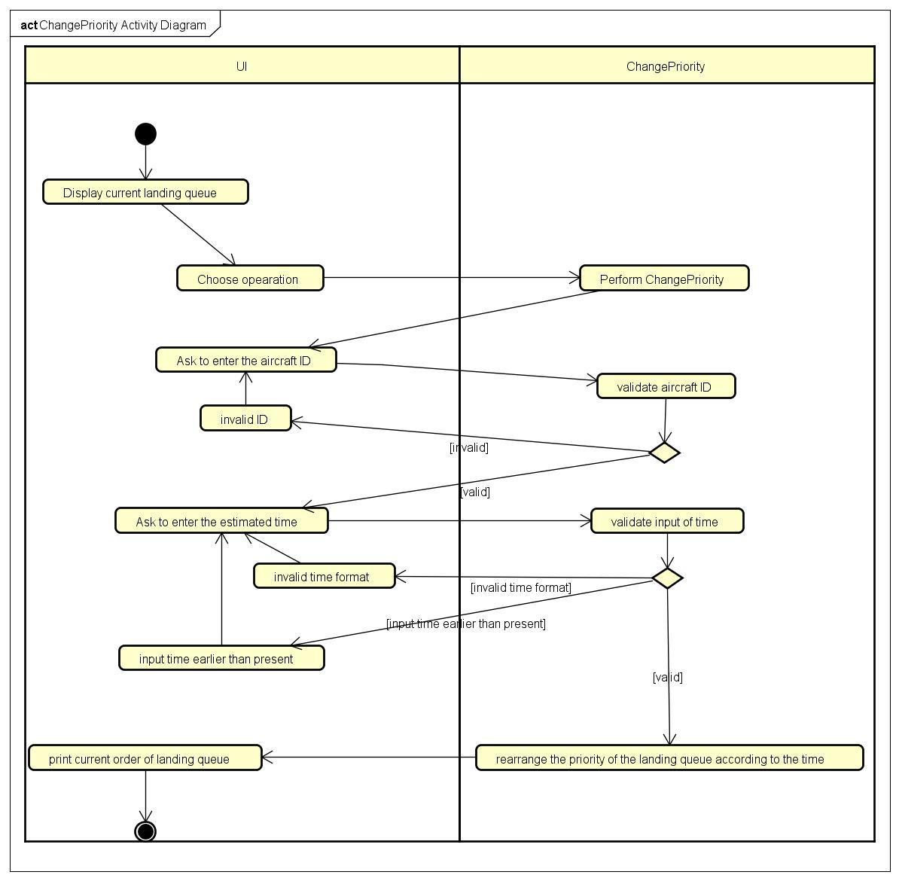

## 7.2 Add new aircraft to landing queue

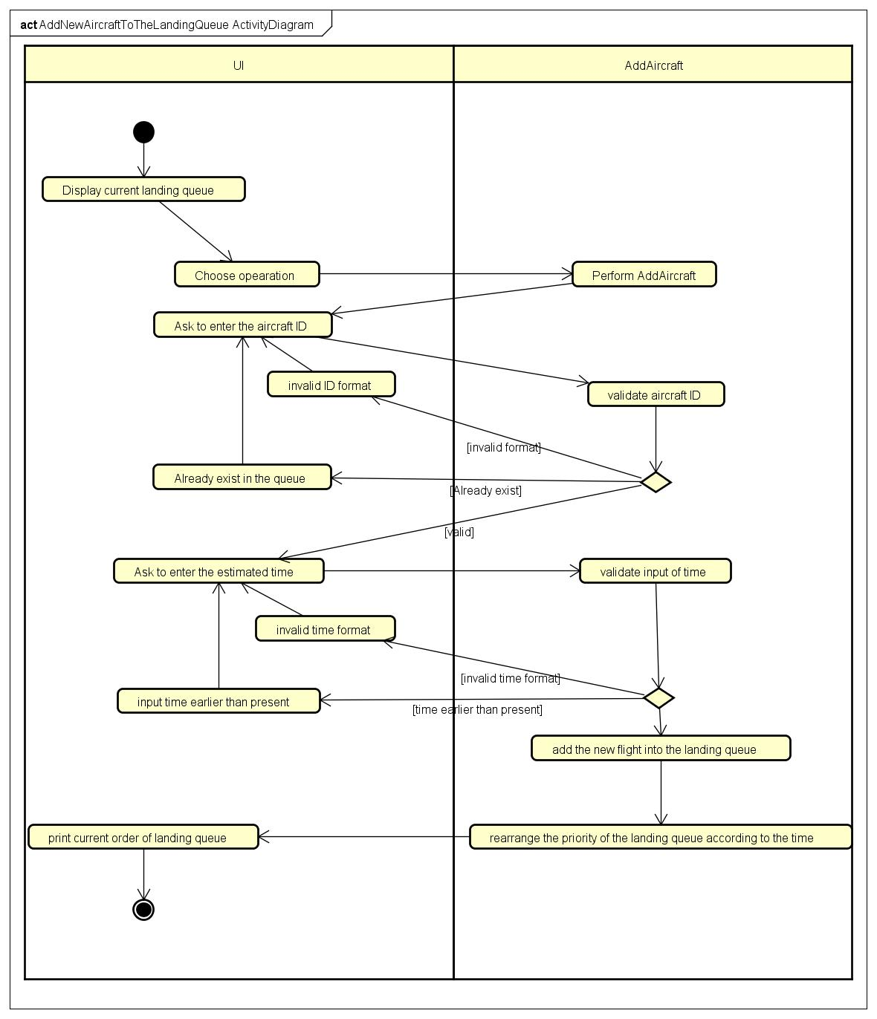

## 7.3 One-to-One Instructions

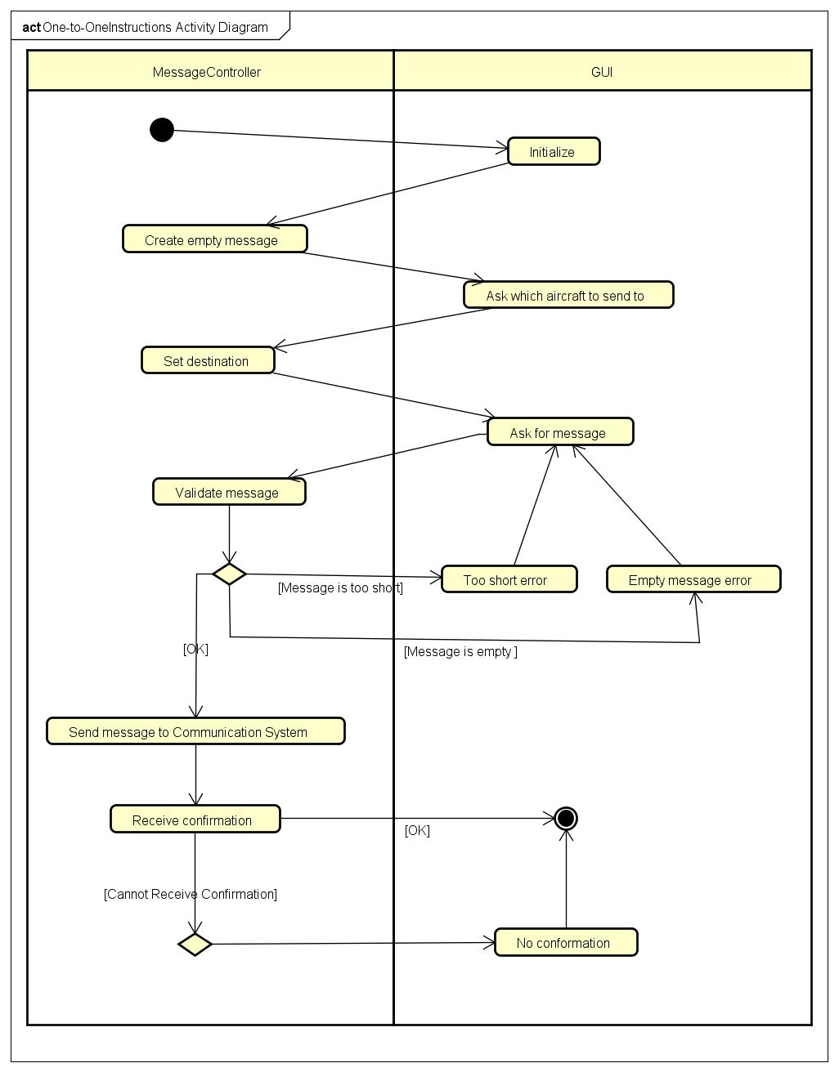

## 7.4 Monitor boarder

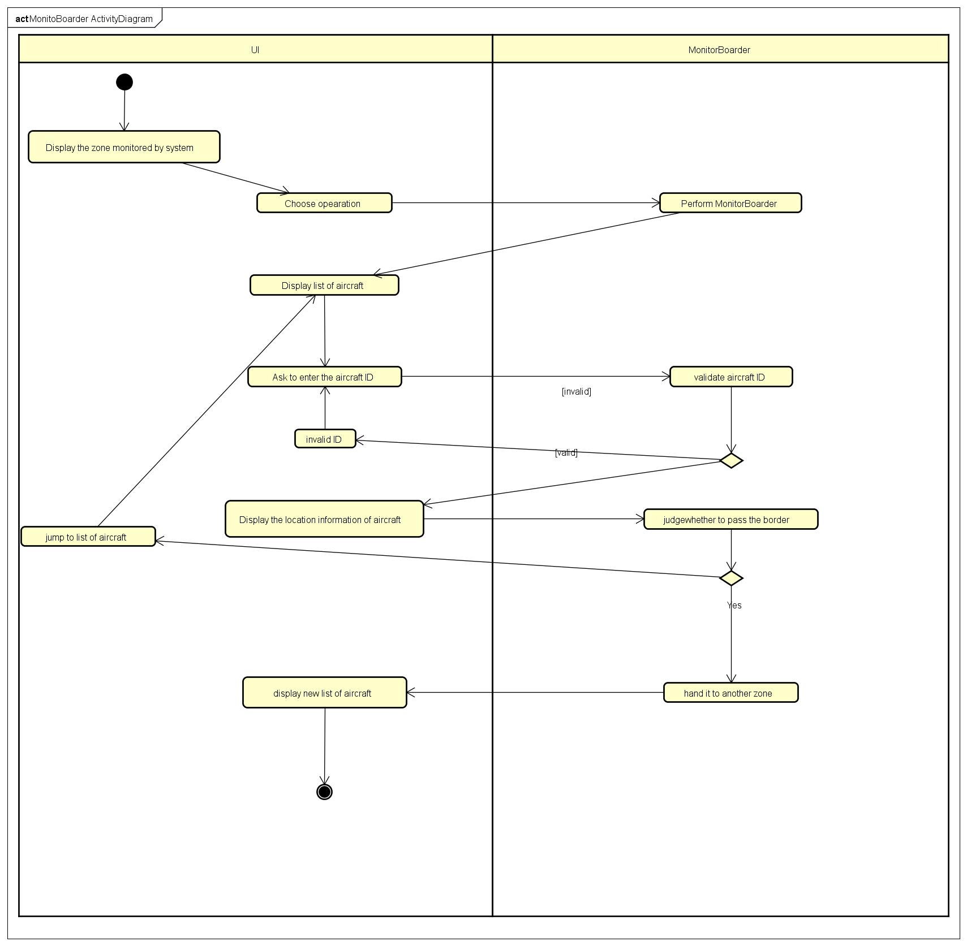

# 8.0 Non-Functional Requirements

|  |  |
| --- | --- |
| **Ref. #** | **Description** |
| NFR01 | Response time of calculating saftety distance should not be more than 1.0 second under normal traffic (aircrafts less than 50) and 1.5 seconds under heavy traffic. |
| NFR02 | System should be able to deal with 1000 user requests at the same time and should allow 3000 users to browse at the same time. |
| NFR03 | Database should not be more than 20GB |
| NFR04 | Minimun disk space is 500G |
| NFR05 | Error of Location should not be more than 50 meters. |
| NFR06 | Round calculation to 6 decimal places |
| NFR07 | Different users have different access, and they can not visit what they don't have access to. |
| NFR08 | System should be able to detect and cope with normal attacks like SQL injection. |
| NFR09 | OS: System should support CentOS 6.5+ and Ubuntu 14+ |
| NFR10 | DB: System should support Oracle 10g and MySQL 5.7+ |
| NFR11 | System supports operation on touchcreens. |
| NFR12 | Possibility of software failure should be less than 2%. |
| NFR13 | System should be able to deal with power dropout and network dropout |
| NFR14 | System should back up the database every 20 days and have at least 2 copies of it. |
| NFR15 | Help documetation should be provided. |
| NFR16 | Regression testing is required during development. |
| NFR17 | Code must pass unit testing and path coverage must be 100%. |
| NFR18 | Methods of any object should have less than 250 lines of code. |
| NFR19 | Code should be fully documentated and every method should be described using comments. |

# 9.0 Release Plan

## 9.1 Release One

|  |  |  |  |
| --- | --- | --- | --- |
| Version | Use Case | Priority | Functional Goal |
| 0.1.0 | Send broadcast instructions | Very High | ATC can send instructions to pilots through the communication system. So ATC can command the aircraft to move. |
|  | Send one-to-one instructions | Very High |

## 9.2 Release Two

|  |  |  |  |
| --- | --- | --- | --- |
| Version | Use Case | Priority | Functional Goal |
| 0.2.0 | Receive message | Very High | Pilots can sent their problems though communication system, so the ATC can respond to the pilots’ problems. |

## 9.3 Release Three

|  |  |  |  |
| --- | --- | --- | --- |
| Version | Use Case | Priority | Functional Goal |
| 0.3.0 | Get aircraft location | High | The safety of the aircrafts can be ensured. |
| Monitor safe distance | High |

## 9.4 Release Four

|  |  |  |  |
| --- | --- | --- | --- |
| Version | Use Case | Priority | Functional Goal |
| 0.4.0 | Display landing and departure seqence | High | The specialist ATC can manage the sequence of the landing and departure queue of the aircrafts. |
| Change aircraft's priority | Medium |
| Remove cancled aircraft from queue | Medium |
| Add new aircraft to queue | Medium |

## 9.5 Release Five

|  |  |  |  |
| --- | --- | --- | --- |
| Version | Use Case | Priority | Functional Goal |
| 0.5.0 | Monitor boarder | Low | ATC can know which aircraft is entering and leaving the boarder. |

# 10.0 Glossary

|  |  |
| --- | --- |
| **Term** | **Definition** |
| ATC | Air Traffic Controller, the person who control the traffic affairs in the airport. The position of air traffic controller is one that requires highly specialized knowledge, skills, and abilities. Controllers apply separation rules to keep aircraft at a safe distance from each other in their area of responsibility and move all aircraft safely and efficiently through their assigned sector of airspace, as well as on the ground. |
| Specialist ATC | A kind of ATC that specialize at arranging the order of the landing/departure sequence of the aircrafts. |
| Zone | The area the airport controls |
| Instructions | The command the ATC gives to the pilot, including when and how to take off/land, fly at a fixed position, fly to another attitude for being too close to the other aircrafts etc. |
| Moniter | An action the ATC does to see all the plane in zone, including moniter the safety of two aircrafts and moniter whether the aircrafts is entering the boarder of our zone. |
| Broadcast | A way the ATC communicate to all the pilots. The ATC can choose to broadcast messages to all the pilots. |

# 11.0 Summary

In our requirements specification, we presented the analysis process of the air traffic controller system. The main user of our system is the air traffic controller, and it will communicate with other system. There are three main functions of our system. 1) moniter the aircrafts 2) communicate with the communication system 3) rearrange the sequence of the landing/departure aircrafts.

The ATC can moniter the aircrafts, including the safe distance between two aircrafts and the aircrafts that are preparing to leave the zone. To implement these functions, the air traffic controller system will first get the location of the aircrafts from the radar system. And our system will calculate the directions between all the aircrafts to moniter whether the aircrafts are all in the safe direction or it is preparing to enter/leave the board. And when bad things happened, our system will alert the ATC.

The ATC can communicate with the pilot through the communication system. The ATC can give instructions to the pilot to move the aircraft to another attitude or height/speed when things happened like two aircrafts getting too close, aircraft need to land/take off at the airport. The ATC will also provide the wheather information, which routes for aircraft to run etc. The ATC can receive the message from the pilot. Which means pilot can also communicate with the ATC through the communication system, and emergency affairs should be transferred in this way.

The Specialist ATC, which is one kind of the ATC, especially responsible for arranging the sequence of the landing/departure aircrafts. The everyday’s flights of an airport is fixed, so our system will initialize the sequence of landing/departure aircrafts every morning when the system is ready. What the Specialist ATC needs to do is to rearrange the sequence of the queue when the emergency affairs occur. The Specialist ATC also needs to add a new aircraft to the landing queue when the aircraft, which is not planned to land at this airport, must land here. Also, the specialist ATC also needs to remove the cancled aircrafts from the queue, etc.

Our Air Traffic Control System can well help the airport to work in an orderly way. Every work the users need to do is explicit and easy to understand. Our system can simplify people’s work. Our system will alert for the safety affairs and the boarding affairs automatically, which means the ATC only needs to concentrate on the communication with the pilot. At the same time, our system can arrange the sequence automatically when it is ready every morning. And when planes take off or land at the airport, system can remove the aircraft from the departure/landing queue automatically, which means the specialist ATC only needs to concentrate on the unprecedented affairs and rearrage the new sequence.

Cost less, do more. This is what our system focuses on.

# 12.0 References

* Air Traffic Control. (n.d.). Retrieved October 31, 2018, from <https://en.wikipedia.org/wiki/Air_traffic_control>
* Air Traffic Controllor. (n.d.). Retrieved November 1, 2018, from <https://en.wikipedia.org/wiki/Air_traffic_control>lor
* How Air Traffic Control Works. (n.d.). How Stuff Works. Retrieved October 31, 2018, from https://science.howstuffworks.com/transport/flight/modern/air-traffic-control.htm